Software Project Management 2021/2022

Flashee

D2.2.1 – Software Architecture and Design

### Authors

* Ângelo Paiva.
* Burak Tinman.
* Jan Frank.
* Álvar San Martin.
* Pedro Henriques.

### Reviewer

* Ângelo Paiva.
* Burak Tinman.
* Jan Frank.
* Álvar San Martin.
* Pedro Henriques.

### Approver

### Table of Contents

1. Introduction

2. System Architecture / Class Diagrams / Activity Diagrams

2.1. System Architecture

2.2. Class Diagrams

2.3. Activity Diagram

# Introduction

The following diagrams describe the system architecture and provide information about how the whole application is going to work.

# System Architecture / Class Diagrams / Activity Diagrams

## System Architecture

## General Architecture Overview

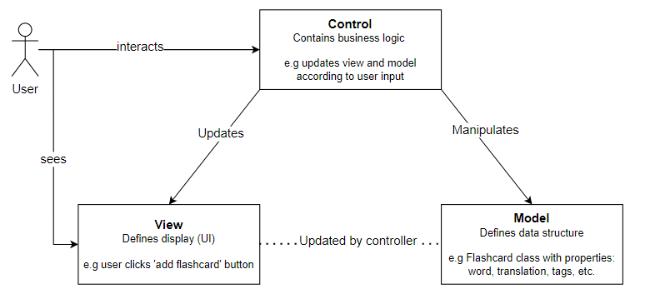

## Class Diagram

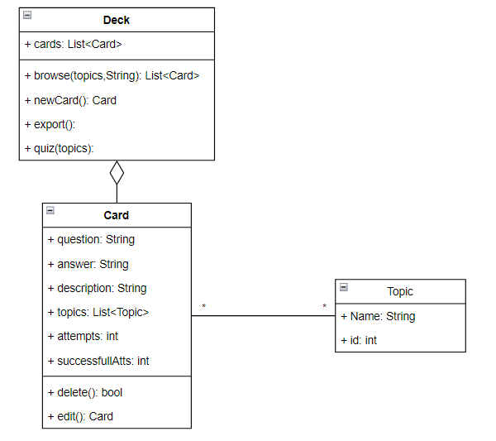

## Activity Diagram (BPMN 2.0)

## UC-01 Create Card

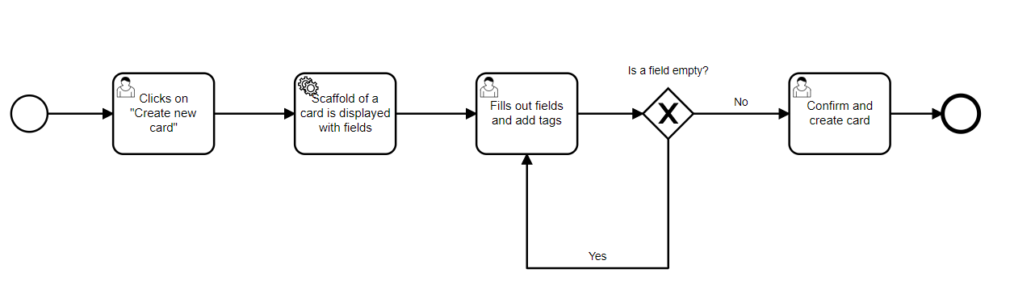

## UC-02 Modify Card

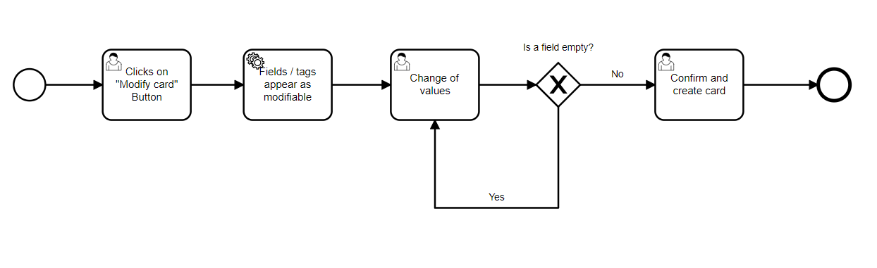

## UC-03 Delete Card

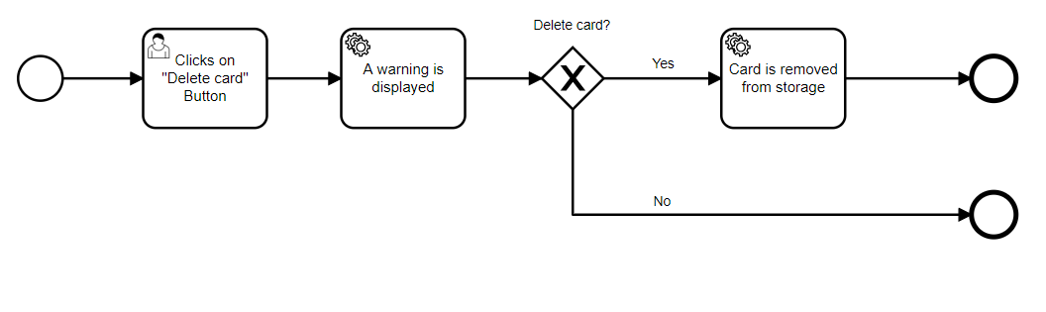

## UC-04 Start quiz

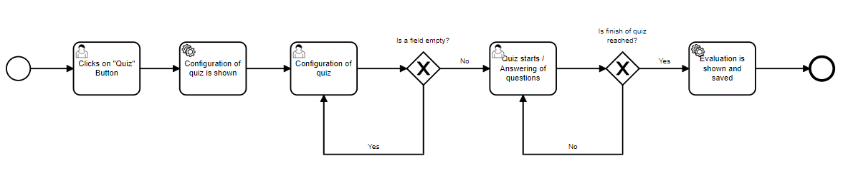

## UC-05 See statistics

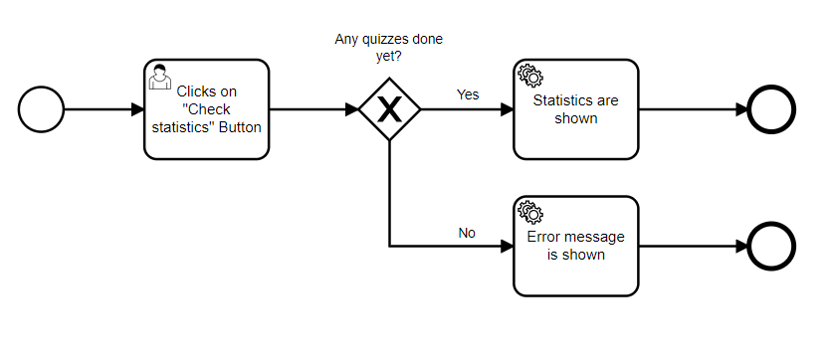

## UC-06 Search for card

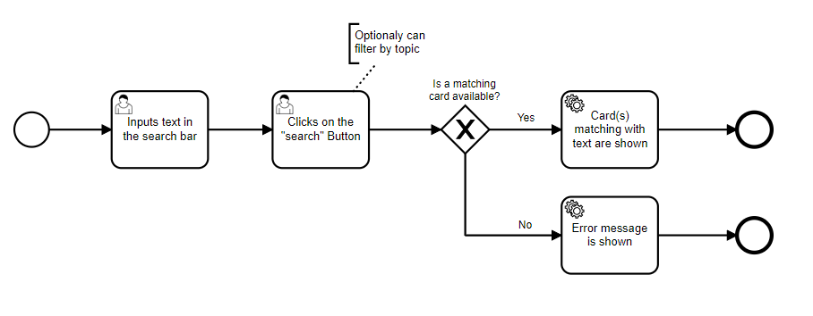

## UC-07 Export deck

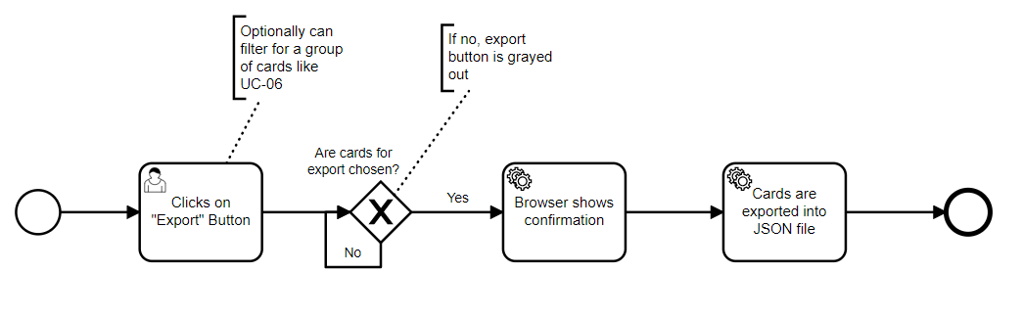

## UC-08 Import deck

